SEQUENTIAL COMPLEXATION BY SIMPLE LIGANDS
These reactions are often viewed as Lewis Acid/Base reactions in which the ligand donates a pair of electrons to a vacant d-orbital of the metal, consider the following example of Ni(II)

Ni(H₂O)²⁺ + 4 Cl⁻ <===> NiCl₄²⁻ + 4H₂O)

Reaction occurs in a number of steps!

Ni²⁺ + Cl⁻ <===> NiCl⁺
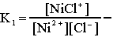
NiCl⁺ + Cl⁻ <===> NiCl₂ -
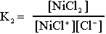
NiCl₂ + Cl⁻ <===> NiCl₃⁻
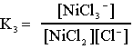
NiCl₃⁻ + Cl⁻ <===> NiCl₄⁻²

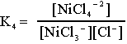
Formation constants are often expressed in terms of the overall reaction rather than the simple steps:
ß₁= K₁ ß₂= K₁K₂ ß₃= K₁K₂K₃ ß₄=K₁K₂K₃K₄
_{for example :}

