Chlorine in water

Because chlorine is widely used as a disinfectant for drinking water, swimming pools, and sewage treatment, it is worth looking at its stability diagram. Note that the effective bactericidal agent is not Cl₂ itself, but its oxidation product hypochlorous acid HOCl which predominates at pH values below its pK_{a} of 7.3. Note also that
- Cl₂ is unstable in water except at very low pH; it decomposes into HOCl and Cl–.

- Hypochlorous acid and its anion are stronger oxidants than O₂ and thus subject to decomposition in water. The only stable chlorine species in water is Cl–

- Decomposition of HOCl occurs very slowly in the dark, but is catalyzed by sunlight. For this reason the chlorine in outside swimming pools must be frequently renewed.

- Decomposition of Cl₂ and HOCl by reaction with organic material in municipal water supply systems sometimes makes it necessary to inject additional chlorine at outlying locations.

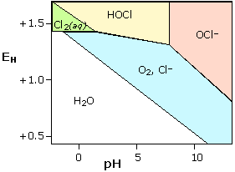 | Stability diagram for chlorine in water  Each solid line represents a combination of E and pH at which the two species on either side of it can coexist; at all other points, only a single species is stable.  Note that equilibria between species separated by diagonal lines are dependent  on both E and pH, while those separated by horizontal or vertical lines are  affected by pH only or E only, respectively.

Cl₂ + 2e === 2Cl⁻ E₀ = 1.36
Acidic H⁺ + HClO + e === ½ Cl₂ + H₂O E₀ = 1.83
Basic ClO⁻ + H₂O + 2e ===Cl- + 2OH⁻ E₀ = 0.84
HClO == H⁺ + ClO⁻ pK_{a}~7.3
O₂ + 4H⁺ +4e === 2H₂O E₀ = 1.23

